Monitoring Sediment and Phosphorus Loads in Runoff from Dairy Feedlot/Exercise Lots to Facilitate Model Parameterization

Final Report

Becky Larson, Biological Systems Engineering Dept., University of Wisconsin-Madison
Dennis Busch, Pioneer Farm, UW-Platteville
Laura Ward Good, Department of Soil Science, University of Wisconsin-Madison
Peter Vadas, USDA-ARS Dairy Forage Research Center, Madison, Wisconsin
John Panuska, Biological Systems Engineering Dept., University of Wisconsin-Madison

Background:
In late 2012 and early 2013 with funding from the Wisconsin Department of Natural Resources (WDNR), UW-Platteville staff installed runoff monitoring equipment on three dairy lots to collect sediment and phosphorus data for model parameterization. The gaging methods are described in Appendix A. Although the original project was to monitor lots within the Six-Mile Creek watershed draining to Lake Mendota, we were unable to locate lot sites within this watershed that were physically suited for monitoring. Three suitable sites were found within the region. A concrete lot and an earthen lot at the USDA-ARS Dairy Forage Research Center (DFRC) Farm were monitored for flow and runoff event samples through 2014. Gaging equipment was set up at an additional earthen lot in Dane County, but changes in lot drainage pathways during snowmelt led to less useful data collection at this site. Dr. Rebecca Larson’s research group from Biological Systems Engineering analyzed event runoff samples for pH, total solids (TS), total phosphorus (TP), total dissolved P (TDP), and ammonia. Conductivity and Total Kjeldahl nitrogen were also measured for some samples. This report summarizes study findings and describes how measured runoff volume, sediment and P correspond to modeled losses predicted by the APLE-Lots and BARNY models.
Summary Results:
Runoff from a concrete lot and two heavily used earth lots exhibited similar phosphorus characteristics, suggesting that manure rather than soil was the dominant total P and solids source in the earth lots’ runoff.
Runoff volume from the concrete lot was more than double that from an adjacent dirt lot for most of the year, but the two lots had similarly very high runoff volumes when the soil was frozen.
For 2014, the APLE-Lots estimated total P loads from the two lots were similar to measured loads, though somewhat higher. In contrast, total P loads calculated with BARNY were higher for the concrete lot and nine times lower than what was measured for the earth lot.

Description of Monitored Lots
DFRC1: The monitored paved lot at the USDA Dairy Forage Research Farm in Sauk County.
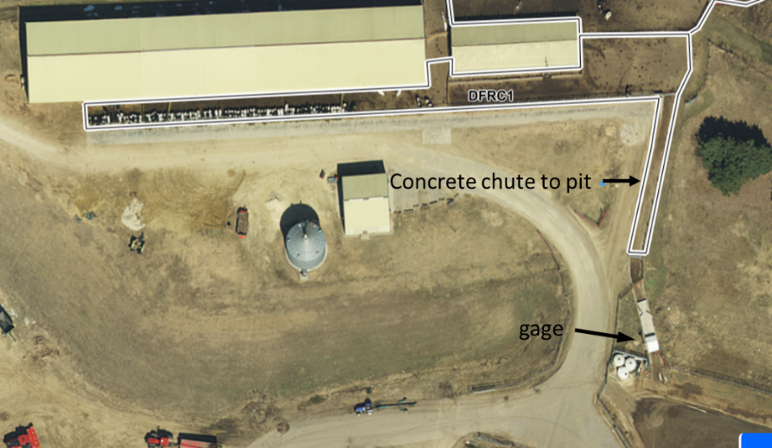
Figure 1. DFRC1 covers 0.27 paved acres and the roofs do not contribute runoff to the
lot.

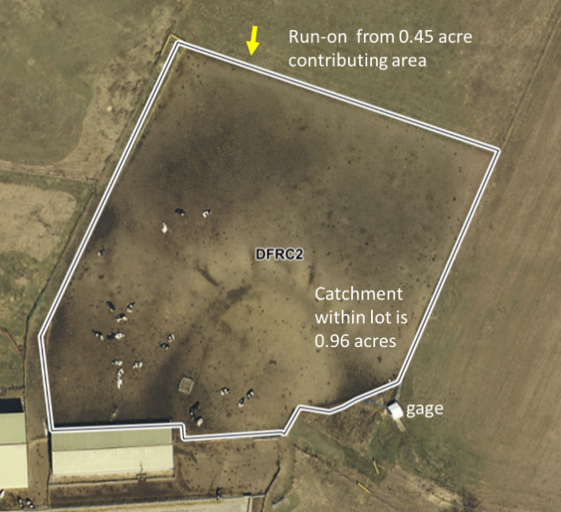
This lot had animals year-round equivalent to 16.25 dairy dry cows, 25 dairy heifers (approx. 1000 lb), and 22 dairy heifers (approx. 750 lb) per day. It was cleaned approximately every 4 days. The gage was located in a concrete drainageway draining to the manure pit (Fig.1). As obstacles to winter gaging operations were overcome, some but not all events were sampled in the winter of 2013-2014.. Flow monitoring captured 18 runoff events in 2013 and 31 in 2014. Not all constituents were measured for every sample (see Table 1 in Barnyard Runoff Sample Analysis section).

Figure 2. DFRC2 is an earth lot receiving drainage from an adjacent grassed field.
DFRC2: This is a dirt lot located adjacent to DFRC1 and was monitored over the same period. It was used by 46 dry cows approximately 1 hour per day in winter (generally December - March) and 12 hours per day the rest of the year. The lot itself is 1.4 acres with 0.96 acres draining to the gage. Part of an adjacent grass field (0.45 acre) drains into the lot. Wing walls constructed in a natural drainage way at the edge of the lot directed flow to the gage as shown in the lower right portion of Figure 2. Flow monitoring captured 18 runoff events in 2013 and 31 in 2014. Not all constituents were measured for every sample (see Table 1 in Barnyard Runoff Sample Analysis section).
Since DFRC2 is an earthen lot, in addition to water quality sampling, soil samples (1-inch and 6-inch) were collected from the lot and tested for soil test P (STP, Bray P1) and organic matter content (OM). The averages for the 6-inch samples (depth for routine agronomic samples, n = 5) were 334 ppm STP and 3.6% OM. For the 1-inch samples (depth representative of the surface that interacts with runoff, n = 6), average STP was 397 ppm and average OM was 10.3%. Downslope of the lot, 30 feet below the gage, values were higher than those within the lot, with 416 ppm and 400 ppm STP and 13% and 8.5% OM for the 1-inch and 6-inch samples, respectively, indicating that infiltration of lot drainage in this area has led to increased soil P and OM values.
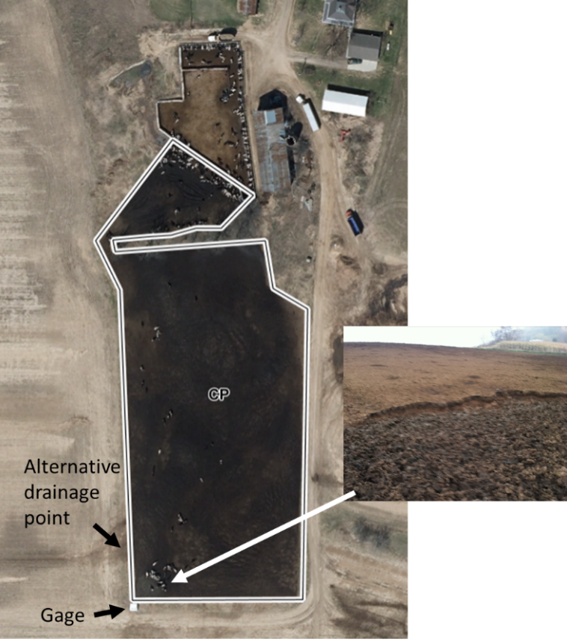
Lot CP: This is a private lot located in Dane County that has since been abandoned. Several hundred heifers shared a concrete lot and the adjacent 3-acre earthen lot. The gage was located on a natural drainage channel for the earthen lot (Figure 3). The surface of the earthen lot appeared to be primarily compacted manure, except for an area on the southwest corner where livestock traffic had broken through this crust and churned up the underlying soil (see inset).
Unfortunately, we were not able to accurately quantify flow volumes at this gage because the area drained by the gage was not constant. During some snowmelt events, an unknown proportion of the flow took an alternate drainage path (Fig.1). While we cannot estimate flow for this site, we do, however, have P, N, and solids concentration data from 22 event samples for this site that are included in the Barnyard Runoff Sample Analysis section below.

Figure 3. Private concrete and gaged earthen lot CP located in Dane County.
Runoff Measurements
Runoff monitoring equipment was installed at the DFRC site late in 2012. The equipment is described in detail in Appendix A. It required considerable troubleshooting over the winter of 2012 - 2013 to ensure accurate runoff volume measurements under freezing conditions. Data collection from this first winter of monitoring was not complete. Runoff volume data is presented here for April – November 2013 (non-frozen), December 2013 – March 2014 (frozen), and April - November 2014 (non-frozen).
Precipitation
The closest local winter precipitation recording gage was located at the Sauk Wastewater Treatment Plant (SWTP, USC00477576). Of the 11 years with complete precipitation records since the station began operation, the April – December 2013 precipitation of 32.4 in was below the average (34.5 in) and the median (34.9 in) for the area. Calendar year 2014 was also somewhat drier than average with 35.1 in total precipitation recorded compared to the average (39.3 in) and median (39.5 in). Note that some daily precipitation data was missing from SWTP and observations from Baraboo (USC00470516) were substituted to compute the precipitation to runoff comparisons below and in the calculation of modeled loads for Tables 4-6.
DFRC1
For April through November 2013, the concrete lot produced runoff during almost every rainfall event, with a total of 24.7 in of runoff from 31.9 in of precipitation (77% ). From December 2013 through March 2014, there were 3.8 in of runoff from 4.2 in of rain and snow water-equivalent (90%). In some of the events, the measured runoff exceeded the accumulated precipitation water equivalent measured at SWTP. Possible explanations for this are variations in precipitation between the DFRC farm and SWTP or drifting snow accumulating on the lot. It is also possible that adjacent areas that would not ordinarily drain to the lot did so when the landscape was covered with snow and ice. For April through November 2014, this lot had 23.3 in runoff from 31.2 in rainfall (75%).
DFRC2
This earth lot generated less than half of the runoff volume of the concrete lot when the soil was not frozen, with 7.9 in of runoff April - November 2013 and 11.5 in April - November 2014. For the frozen months of December 2013 through March 2014, this lot produced 6.1 in of runoff, considerably more than the 4.2 in of precipitation. Greater runoff depth than measured precipitation can be explained by snowmelt run-on from the adjacent grassed area (Fig. 2). In addition, blowing and drifting causes an uneven distribution of snow across the landscape and it is possible that there was a greater accumulation of snowpack within the lot. Also, as for DFRC1, the precipitation measurements from SWTP may not be completely representative of this site.
Barnyard Runoff Sample Analysis
Solids and Phosphorus
Table 1. Total solids, total phosphorus (TP), Total and dissolved phosphorus (TDP) concentrations in lot runoff, particulate P (PP) in lot runoff solids, and the ratio of total P to solids in runoff from three dairy animal lots.
 | Total Solids |  |  | Phosphorus
 | Sample | Mean (range) | Sample |  | Mean TP  (range) | Mean TDP (range) | Particulate P¹ |  | Total P/Solids
 | # | % |  | # | mg/L | mg/L | mg PP/kg solids |  | TP mg/Solids kg
DFRC1 (Paved)
2013 | 21 | 0.85  (0.31-1.55) |  | 29 | 53.9  (20.4-105) | 37.5  (14.3-85) | 1581 |  | 5663
2014 | 16 | 0.47  (0.07-1.65) |  | 16 | 31.2  (9.1-47.2) | 24.4  (6.0 – 8.7) | 1263 |  | 5651
DFRC2 (Earth)
2013
Jan - March | - | - |  | 5 | 7.4  ( 0.4-13.3) | 5.9  (0.2-11.2) | - |  | -
April - Nov² | 8 | 0.36  (0.24-0.60) |  | 13 | 24.3  (6.4-39.2) | 17.7  (6.3-25.7) | 1765 |  | 7635
2014
Jan - March | 8 | 0.14  (0.01-0.65) |  | 8 | 12.9  (2.7-21.9) | 12.1  (2.2-21.4) | 568 |  | 14409
April - Nov² | 12 | 0.47 |  | 12 | 25.7  (13.6-40.2) | 18.5  (9.5-30.0) | 1686 |  | 5930
Lot CP (Earth)
2013 | 2 | 1.73 |  | 10 | 127.1  (3.8-590) | 72.8  (3.1-233) | -- |  | --
2014 | 12 | 0.69  (0.11-0.34) |  | 11 | 37.5  ( 15.4-69.3) | 30.95  (13.7-62.3) | 564 |  | 6645
¹ Particulate P is the P concentration of the solids and is calculated as (TP-TDP)/TS.
² No December events were monitored in 2013 or 2014.
Mean Solids and P concentrations varied across the lots and from year to year (Table 1). The CP lot runoff had the highest mean TP and solids concentrations in each year, which is reflective of its manure-covered surface (Fig. 3). DFRC1 had the next highest concentrations. The DFRC2 results are displayed as January through March and April through November to show that solids and total P in runoff were generally lower in the winter months when average herd lot use dropped from 12 hours to 1 hour per day.
Similarities in the characteristics of the P in the runoff from the two heavily used earth lots with that of the concrete lot suggest that manure was the dominant total P and solids source in the earthen lot runoff with little influence from the soil. There was a strong relationship between TP and TDP across all runoff events and sites (R² = 0.97), with about 72% of the total P in the runoff was in the dissolved form (Fig. 4). Except for those measured at DFRC2 January through March 2014, the TP to Solids ratio is consistent and within the range of measured dairy manure P concentrations. For comparison, the typical dairy manure TP concentrations used in APLE-Lots range from 5,400 mg/kg for calves and heifers to 8,800 mg/kg for lactating cows. The higher TP/Solids values for the winter period at DFRC2 are a result of 5 of the 8 samples having very low solids contents of < 0.05%.

Figure 4. Relationship between total P and total dissolved P for event runoff samples from three dairy lots.
Some samples were also analyzed for total N or ammoniacal N. A description of these analyses are included in Appendix B.
Phosphorus Loads
Phosphorus loads (lb/acre) for DFRC1 and DFRC 2 are shown in Table 2 on a pound per acre basis to facilitate comparisons of the differences in runoff and loading resulting from lot surface type and management. Even though it was regularly cleaned (approximately every 4 days), DFRC1 had higher total P loads due to higher P concentrations and greater runoff volumes.
Table 2. Total P loads from April 2013 through November 2014 on adjacent concrete (DFRC1) and earth (DFRC2) lots.
 | Concrete | Earth
 | lb./a | lb./a
April 2013 through November 2013 | 231 | 46
December 2013 through March 2014 | 33 | 19
April 2014 through November 2014 | 135 | 83

Comparing Measured and Modeled Loads
We compared measured P loads at DFRC1 and DFRC2 with modeled loads from the Wisconsin version of APLE-Lots. We used the APLE-Lots Wisconsin calculations as described in the APLE-Lots for Wisconsin Technical Manual (included as Appendix C). Daily precipitation, snowfall, standing snow, and temperature data needed for determining the daily water available for runoff came from SWTP (supplemented with observations from Baraboo when data were missing). With the available data, we were able to calculate and compare APLE-Lots-Wisconsin results to measurements for the non-frozen season runoff in 2013 (April-November, Tables 3 and 4) and the entire calendar year of 2014 (Tables 5 and 6). In addition, in the comparisons for 2014, we were able to include results from the APLE-Lots spreadsheet and BARNY in the analysis because we had a complete year of monitoring data and those spreadsheet models calculate on an annual basis.
APLE-Lots Wisconsin uses the same equations as the APLE-Lots spreadsheet created by Peter Vadas (2014, found at APLE Lots : USDA ARS) with some modification. The primary differences are that APLE-Lot’s Wisconsin uses county-specific precipitation event distributions based on weather records (rather than annual rainfall averages), calculates frozen soil runoff on earthen lots with a modified curve number method to account for reduced infiltration, and allows animals present on the lot to vary by season. Another difference is that APLE-Lots Wisconsin uses equations from the WI P Index to estimate the earthen lot soil contributions to runoff dissolved and sediment P. For this comparison, we used the version of BARNY from the WDATCP Livestock Siting Application Materials website: (https://datcp.wi.gov/Pages/Programs_Services/LSAppMaterials.aspx).
Table 3. Measured and APLE-Lots Wisconsin calculated rainfall runoff, P, and solids for a concrete lot (DFRC 1) April-November 2013.
 | Measured | APLE-Lots WI*
Rainfall runoff (in) | 24.7 | 25.4
Dissolved P (lb.) | 45 | 18
Sediment P (lb.) | 17 | 36
Total P (lb.) | 62 | 54
Solids (ton) | 5.5 | 3.1
*Calculated with precipitation measured at the Sauk Wastewater Treatment Plant. Event precipitation was used for calculating event runoff and the measured annual rainfall total was used for calculating the curve number.

Table 4. Measured and APLE-Lots Wisconsin calculated rainfall runoff, P, and solids for an earthen lot (DFRC 2) April-November 2013.
 | Measured | APLE-Lots WI*
Rainfall runoff in | 7.9 | 15.5
Dissolved P (lb.) | 34 | 21
Sediment P (lb.) | 10 | 69**
Total P (lb.) | 44 | 90
Solids (ton) | 3.1 | 23**
*Calculated with precipitation measured at the Sauk Wastewater Treatment Plant. Event precipitation was used for calculating event runoff and the annual rainfall total was used for calculating the curve number.
** If calculated with measured runoff rather than modeled, estimated sediment P loss was 23 lb and solids loss was 7.6 tons.

Table 5. Measured and Modeled rainfall runoff, P, and solids for a concrete lot (DFRC 1) in 2014.
 | Measured | APLE-Lots WI* | APLE-Lots spreadsheet** | BARNY***
Winter (Jan-Mar) runoff (in) | 3.8 | 2.1
Rainfall (Apr-Dec) runoff (in) | 23.3 | 24.5
Annual runoff (in) | 27.1 | 26.7 | 28.2
Dissolved P (lb) | 35.2 | 19 | 23
Sediment P (lb) | 10.1 | 39 | 46
Total P (lb) | 45.4 | 56 | 69 | 69
Solids (ton) | 4.0 | 3.4 | 4.1
*Calculated with precipitation measured at the Sauk Wastewater Treatment Plant. Event precipitation was used for calculating event runoff and the annual rainfall total was used for calculating the curve number.
** Calculated using 2014; 35.1-in annual precipitation total from Sauk Wastewater Treatment Plant.
*** Calculated using Madison rainfall file with “Heavy” use. Uses a constant runoff TP concentration of 85 mg/L with much lower total runoff.

Table 6. Measured and Modeled rainfall runoff, P, and solids for an earthen lot (DFRC 2) in 2014.
 | Measured | APLE-Lots WI* | APLE-Lots orig. spreadsheet** | BARNY***
Winter (Jan-March) (in) | 6.1 | 1.3
Rainfall (April-Dec) (in) | 11.5 | 15.4
Annual runoff (in) | 17.6 | 16.7 | 16.3
Dissolved P (lb.) | 75 | 21 | 8
Sediment P (lb.) | 24 | 81 | 105
Total P (lb.) | 99 | 92 | 111 | 10.7
Solids (ton) | 7.4 | 25.1 | 23.9
*Calculated with precipitation measured at the Sauk Wastewater Treatment Plant. Event precipitation was used for calculating event runoff and the annual rainfall total was used for calculating the curve number.
** Calculated using 2014; 35.1in annual precipitation total from Sauk Wastewater Treatment Plant.
*** Calculated using Madison rainfall file with “Heavy” use. Uses a constant runoff TP concentration of 10.12 mg/L.

With only one complete year of monitoring data for each lot, this is not a sufficient test of the APLE-Lots Wisconsin model. However, the comparison does point to areas for future investigation. Although the total P calculated in APLE-Lots was generally close to what was measured (except for DFRC2 for rainfall runoff in 2013, Table 4), the distribution between dissolved P and sediment P was substantially different. APLE-Lots sediment P was always higher than dissolved P, while the reverse was measured. A likely explanation for the higher dissolved P measured in runoff is that P continued to solubilize from manure particulates following their detachment by runoff. Note that this shift in form during transport from the lot in runoff is not a concern for APLE-Lots Wisconsin software users as this software reports total P rather than separate dissolved and particulate P loads.
Another point for future investigation is that APLE-Lots appears to overestimate solids loss for the DFRC2 earth lot (Tables 4 and 6), but not the paved lot (Tables 3 and 5). Runoff solids for the monitored earth lots used to develop the solids loss equation in APLE-Lots were composed of mixtures of manure solids and soil (Vadas et al., 2015). Manure solids typically have a lower specific gravity (due to higher organic matter content) than that of mineral soil. Thus, runoff solids composed primarily of manure particles will have a lower unit mass than those containing a mixture of soil and manure solids. As previously stated, the solids from the DFRC2 lot appear to be primarily composed of manure solids, therefore resulting in a lower unit solids mass loss than that predicted by APLE-Lots. To illustrate this point, if the paved lot equation (which assumes that all runoff solids are manure particles) is applied using the measured runoff volume for April to November 2013, the estimated load is 1.7 tons of solids and for 2014 it is 6.7 tons, which are more comparable to the measured solids loss of 3.2 and 7.4 tons, respectively (Tables 4 and 6). We do not know if this earth lot is unique in its lack of soil erosion. During soil sampling, we observed that this lot was very compacted at the surface. This lot’s soils are mapped as St. Charles and McHenry silt loams, which are both very erodible compared to most Wisconsin soils (K = 0.43 and 0.49). It is possible that over many years of use, the surface has become so altered and compacted that it is less susceptible to erosion.
When comparing the models in 2014 (Tables 5 and 6), the APLE-Lots Wisconsin and APLE-Lots spreadsheet results were similar, but the Wisconsin version’s were closer to the monitored results. This probably reflects the use of daily precipitation events in calculating runoff volume in APLE-Lots Wisconsin rather than the spreadsheet’s distribution derived from annual runoff volume. BARNY overestimated the annual P loads for the concrete lot (Table 5) and grossly underestimated it for the dirt lot (Table 6). In APLE-Lots, runoff P concentrations vary with lot runoff volume and the amount of manure deposited. In contrast, BARNY’s runoff P concentrations are assigned by lot type. BARNY’s fixed runoff TP concentration from the concrete lot was 85 mg/L, far exceeding the measured mean TP concentrations of 53.9 mg/L in 2013 and 31.2 mg/L in 2014 (Table 1). Conversely, BARNY’s fixed TP concentration for the dirt lot of 10.1 mg/L was lower than most event measurements (Table 1). The low TP concentration estimate combined with a lower runoff volume estimate to produce a TP load estimate that was only 11% of the measured load.
Conclusion
This study examined runoff P concentrations for one concrete dairy lot and two earthen lots in 2013 and 2014 in South Central Wisconsin. Based on their P characteristics, the dominant solids material in runoff from all three lots appears to be manure. The lot with the most manure coverage on the surface had the highest total P and solids concentrations. The concrete lot had a higher runoff volume than an adjacent earthen lot except when the soil was frozen. On a per acre basis, the concrete lot also had higher total P and solids losses. Results from the APLE-Lots-Wisconsin model aligned more closely with the measured runoff P for both lots than the BARNY model.

APPENDICIES

Appendix A.

Lot Runoff Monitoring Equipment

The lot runoff monitoring equipment was located in pre-fabricated buildings, located at the edge-of-field where overland runoff was directed and concentrated (Fig. A1-C). To properly site the edge-of-field runoff collection station, natural topographic, grassed waterways or other engineered management features and field watershed boundaries were accounted for. The runoff collection station, was comprised of four main components: 1) a Modified HXL-Flume with Integrated Heat System (Fig.A1-B), 2) Ultrasonic Stage Sensor, 3) Integrated User Interface, and 4) Stage Camera (Fig. A1-A). The station was powered by deep cycle marine batteries capable of supplying 100 amp hours of power. Solar panels recharged the batteries with a supply of 18 amp hours/day during winter daylight conditions.
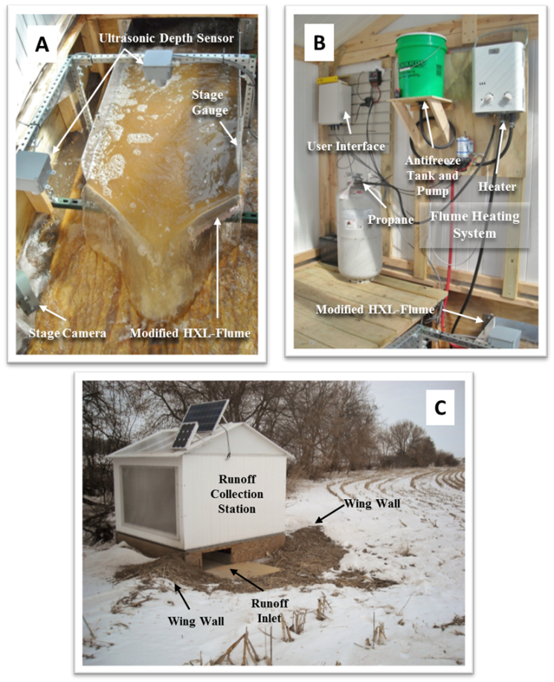
Figure A1. Pictures of field runoff monitoring stations showing: A) a modified HXL-flume under runoff conditions, B) details of the modified HXL-flume heating system as well as data logging and user interface system, C) external view of monitoring station.
Modified HXL-Flume with Integrated Heating System
The use of pre-calibrated devices for measuring edge-of-field runoff is common for on-farm research and monitoring programs. Specifically, the H-flume is frequently used in edge-of-field monitoring applications because they accurately estimate discharge, and they can transport solids with little obstruction. Unfortunately, the H-flumes are costly to purchase and require significant in-field berming to direct flow into the flume when measuring larger discharges. Moreover, the flumes require significant labor during the winter in northern climates to keep the device ice-free so discharge can be accurately estimated.

In response to the challenges associated with the use of H-flumes for measuring edge-of-field discharge in northern climates, the modified HXL-flume (MHXL-flume) was developed (Fig. A2). This prototype flume is designed to gauge low flow rates through a convergence section, while high discharge rates overtop the convergence section and allow for larger discharge measurements at lower heads than traditional H flumes. Moreover, to reduce operational costs during winter runoff monitoring, a heat pan was integrated into the floor of the flume to allow circulation of heated fluid beneath the flume. The heat pan is turned on by an on-site technician to release ice from the metal surface and expedite cleaning.

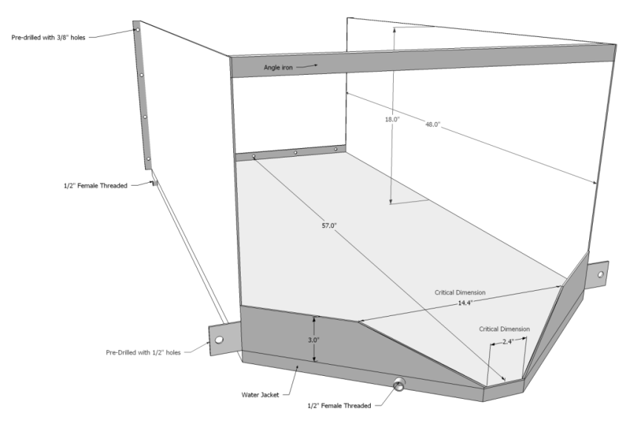
Direction
of flow
Figure A2. Schematic of the MHXL- flume.

The innovative MHXL-flume reduced both installation and labor costs. The low-profile of the MHXL-flume resulted in soil berms (Fig. A1-C) that were smaller in both height and length than what would have been required for equivalent H-flume installations. The integrated heater also proved to be a significant time savings for removing ice of any thickness. Within ten to twenty minutes of heating, the bond between the flume and the ice would melt and the ice could easily be removed (Fig. A3). Conventional flumes require hours of manual labor to break and remove ice in small pieces. The propane RV shower heater (Fig. A1-B) was prone to damage caused by mice and openings were covered with hardware cloth to keep mice out.

To reduce cost, alternative flumes were constructed using state-of-the-art CNC metal cutting and bending techniques. This manufacturing technique reduces cost of flumes by approximately 60%. Several of these flumes were evaluated at the St. Anthony Falls Laboratory (SAFL) in Minneapolis, Minnesota to determine accuracy and precision of discharge estimates (Fig. A4).

Ultrasonic Stage Sensors
Ultrasonic stage sensors (Fig. A1-A) were used to measure water stage (depth) in the flume which is then used to estimate discharge via a rating curve generated through experimentation at SAFL. Field testing indicated that the sensors accurately estimated water stage values.
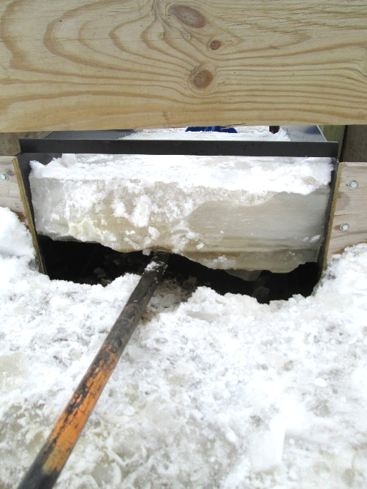
Figure A3. Thick ice easily removed after running the flume heater for ten minutes.

Figure A4. MHXL- flume flowing at St. Anthony Falls Laboratory.

Appendix B.
Nitrogen in Runoff from Three Dairy Lots
Dr. Rebecca Larson and Jenna Walsh
Although not initially outlined in the proposal, additional analysis was conducted on a subset of the runoff samples, Table B-1, to assess the concentration of total Kjeldahl nitrogen (TKN) and total ammoniacal nitrogen (TAN, which includes both NH₄ and NH₃). Both parameters were assessed at the University of Wisconsin-Madison Biological Systems Engineering Department water quality laboratory according to US EPA Method 350.1 v.2 for TAN and 351.2 v.2 for TKN using an automated AQ2 discrete analyzer (SEAL).
Table B-1: Samples analyzed for TKN and TAN.
Site | Area (acre) | Total samples for nutrient analysis | TAN samples | TKN samples | Sample points with TKN and TAN
DFRC1 | 0.3 | 58 | 47 | 12 | 4
DFRC2 | 1.4 | 38 | 25 | 11 | 4
Cross Plains |  | 22 | 16 | 10 | 7
Both TKN and TAN were highly variable at each site, although TKN was less variable across sites than TAN. The variability of the TKN data may be less as these data came from a smaller timeframe as compared to the TAN samples which covered a larger portion on the storms (all TKN data was collected in 2014). A subsample of the storms which had both TKN and TAN concentrations were used to develop a relationship between the two parameters that if extrapolated would suggest that the average TKN for the dirt lot sites, DFRC2 and Lot CP, would be slightly higher and for DFRC1 it would be much higher. At DFRC1 two very high TAN samples (without corresponding TKN samples) increased the average and standard deviation significantly. However, developing a relationship for TKN and TAN from the small sample numbers which had both TKN and TAN concentrations reported may be misleading as the relationship between the two is not strong across all sites or at individual sites, Figures B-1 and B-2.

Table B-2: TKN and TAN by site and year.
Site | TKN  Avg  (mg/L) | TAN  Avg  (mg/L) | TKN  Med  (mg/L) | TAN  Med  (mg/L) | TKN  Std. Dev  (mg/L) | TAN  Std. Dev  (mg/L) | Fraction of TKN which is TAN (%)† | Fraction of TKN which is TAN (%)††
DFRC1 2013 | n/a | 414 | n/a | 282 | n/a | 345 | n/a | n/a
DFRC1 2014 | 201 | 186 | 135 | 45 | 176 | 289 | 92 | 19
DFRC2 2013 | n/a | 8 | n/a | 6 | n/a | 8 | n/a | n/a
DFRC2 2014 | 135 | 23 | 101 | 21 | 88 | 17 | 17 | 4
Lot CP 2013 | n/a | 156 | n/a | 92 | n/a | 197 | n/a | n/a
Lot CP 2014 | 204 | 50 | 209 | 32 | 73 | 49 | 25 | 18
† relationship developed using average TKN and Average TAN values for the year.
†† relationship developed using samples from runoff events which had both a TKN and TAN concentration reported.

Figure B-1: TAN vs TKN all sites combined.

Figure B-2: TAN vs TKN sites separated.

Annual loads calculated using average measured TAN and TKN values are shown for both lots in Table B-2 and B-3. Similar to P loads, unit area N loads were higher for the concrete lot than the earth lot due to higher concentrations and more runoff.
Table B-2: TKN and TAN Loadings at DRFC1 by year
Year | Total Runoff Volume | Total Runoff Volume per Unit Area | TKN Load using Avg. Conc. | TAN Load using Avg. Conc. | Total TKN Load per Unit Area | Total TAN Load per Unit Area
 | (m³) | (m³ ha⁻¹) | (kg) | (kg) | (kg ha⁻¹⁾ | (kg ha⁻¹⁾
2013 | 760 | 6956 | n/a | 314 | n/a | 2880
2014 | 784 | 7173 | 201 | 186 | 1442 | 1334

Table B-3: TKN and TAN Loadings at DRFC2 by year
Year | Total Runoff Volume | Total Runoff Volume per Unit Area | TKN Load using Avg. Conc. | TAN Load using Avg. Conc. | Total TKN Load per Unit Area | Total TAN Load per Unit Area
 | (m³) | (m³ ha⁻¹) | (kg) | (kg) | (kg ha⁻¹⁾ | (kg ha⁻¹⁾
2013 | 939 | 1,666 | n/a | 8 | n/a | 13
2014 | 1,720 | 3,049 | 232 | 40 | 412 | 70

Appendix C.

APLE-Lots for Wisconsin
Technical Documentation

TECHNICAL DOCUMENTATION
Web-Based Model Version

ANNUAL

PHOSPHORUS

LOSS

ESTIMATOR

FOR WISCONSIN ANIMAL LOTS-WI

Model Developers

Peter Vadas, USDA-ARS, Formerly U.S. Dairy Forage Research Center, Currently National ARS Research Leader
Laura Good and Jim Beaudoin, UW-Madison, Department of Soil Science
John Panuska, UW Extension, Biological Systems Engineering

March 2021
Acknowledgements

The model developers would like to express their thanks to the APLE-Lots Advisory Committee that provided valuable insight, feedback and guidance during the model development process.

Matt Woodrow, WI Department of Agriculture and Consumer Protection
Drew Zelle, WI Department of Agriculture and Consumer Protection
Paul Sebo, Washington County Land Conservation Department
Chris Arnold, Columbia County Land Conservation Department
Scott Mueller, USDA - Natural Resources Conservation Service
Alexis Straka, USDA - Natural Resources Conservation Service
Bernie Michaud, WI Department of Natural Resources

The APLE-Lots website and this technical guidance development was supported by the U.S. Department of Agriculture, Agricultural Research Service, under agreement No. 58-5090-5-053.

Any opinions, findings, conclusion, or recommendations expressed in this publication are those of the author(s) and do not necessarily reflect the view of the U.S. Department of Agriculture

Introduction

Pollution of surface waters by phosphorus (P) and the associated accelerated eutrophication of receiving waters continue to pose significant environmental quality challenges. Phosphorus loss from farms via surface runoff is as a major non-point pollution source. For dairy and beef farms, P loss originates from cropland, grazed pastures, and open-air cattle lots, such as feedlots, barnyards, exercise lots, or over-wintering lots. From a whole-farm perspective, P loss from all sources should be estimated to effectively identify the major P sources to target remediation practices. Research shows cattle lots can be significant sources of P loss for two reasons. First, the high concentration of cattle leads to high rates of manure deposition and P accumulation relative to pastures and cropland. Second, cattle holding areas can be partially or completely devoid of vegetation and have compacted soil or an impermeable (e.g., concrete) surface, which can lead to high rates of runoff. This combination of a concentrated P source and transport pathways creates the potential for high rates of P loss.
In areas with both non-point source P pollution issues and a high prevalence of cattle farms with outdoor lots, there is a need to assess the P loss impact of lots relative to other land uses on farms to see if alternative lot management is needed and cost-effective. Computer models can be cost- and time-effective tools to help quantify P loss from farms and identify alternative management practices that reduce the impact of agriculture on water. We developed this implementation of the APLE-Lots model described by Vadas et al. (2015) to estimate P and sediment loss in runoff from cattle lots in Wisconsin.

APLE-Lots Description

The goal of the model is to estimate average annual P and sediment loss from lots.
APLE-Lots is intended to be user-friendly and does not require extensive input data to operate. All data are input directly into the user interface (See APLE-Lots User Notes/Quick Guide). Lot information is entered into a GIS-system where lot boundaries and contributing areas can be drawn over aerial photos and soil maps. The model also supports tabular input via a no-map feature. User-input data include:

- The area of the lot (sq ft).
- Location of the lot (county is required).
- The number and type of cattle on the lot, including beef cattle and calves, dairy lactating and dry cows, and dairy heifers and calves and hours per day they are on the lot (animals on the lot can vary by month).
- The number of days between lot cleanouts (scraping) for paved lots.
- The surface type (paved or earthen) and the % vegetative cover for earthen lots.
- Area and surface type (or curve number) of areas contributing flow to the lot.
- The volume of a functional sedimentation basin (if present).
- The existence of any run-on flow diversions and percent of flow diverted.
- Soil test P (Bray P) and organic matter (%) for earthen lots (optional).

Model Algorithms

The total annual runoff P (TP) at the edge of a paved lot is calculated as dissolved P (DP) released from manure plus the P in manure sediments in lot runoff.
` Paved lot TP= manure DP + sediment P (1)
For an earthen lot, the underlying soil is added as a source of dissolved P and sediments in lot runoff P.
Earth lot TP = manure DP + soil DP + sediment P (2)
These calculations require estimating the accumulation of manure P on the lot and lot runoff. APLE-Lots calculates solids and P loss for the frozen ground (FG) (Dec. – Mar.) (4 month = 121 day) period and the non-frozen ground (NFG) (Apr. - Nov.) (8 month = 244 day) period.

Manure Production and Phosphorus Content by Animal Type

Calculating manure loss from a lot requires first estimating the manure dry matter (DM) and P mass present on the lot. APLE-Lots users enter the number of animals on the lot by animal type (shown in Table 1) and the number of hours per day each type is present. Animal numbers and hours can be constant for the whole year or can vary by season and by month.

Table 1. Daily feces production and fecal total P content by animal type.
Animal Type | Daily Dry Matter (DM) Fecal Production per Head  (lb/day) | Daily Fecal Total P  (manure P content)  (lb/day)
Dairy Calf 150 lbs.  Dairy Calf 250 lbs.  Dairy Young stock 500 lbs.  Dairy Heifer 750 lbs.  Dairy Heifer 1000 lbs.  Dairy Lactating Cows 1000 lbs.  Dairy Lactating Cows 1200 lbs.  Dairy Lactating Cows 1400 lbs.  Dairy Lactating Cows 1600 lbs.  Dairy Dry Cows 1000 lbs.  Dairy Dry Cows 1200 lbs.  Dairy Dry Cows 1400 lbs.  Dairy Dry Cows 1600 lbs.  Beef Calf 450 lbs.(confinement)  Beef Calf 650 lbs.(confinement)  Beef Finishing 750 lbs.  Beef Finishing 1100 lbs.  Beef Cow 1200 lbs.  Beef Bulls 1600 lbs.  Goat 170 lbs.  Sheep 100 lbs.  Horse 1100 lbs. | 1.3  2.4  4.6  6.4  8.4  14.3  17.2  20.1  22.9  9.0  9.7  10.4  10.8  4.2  6.0  4.0  5.7  14.6  10.8  2.2  1.1  8.4 | 0.007  0.013  0.025  0.035  0.045  0.126  0.151  0.177  0.202  0.055  0.059  0.063  0.066  0.039  0.055  0.037  0.053  0.097  0.072  0.008  0.009  0.028
_____________________________________________________________________________________
Sources: Vadas et al. (2015); ASAE, (2005); Lorimor et al. (2004); Johnson and Eckert (1995), USDA-NRCS (2008).

Daily animal numbers and the daily dry matter and total P excretion values in Table 1 are used to calculate separate values for the average daily DM and TP excreted on the lot during the FG and NFG seasons.

DailyDMtotal = Sum for all animal types of (AvDailyHead x DailyDMperHead) (3)

Where the DailyDMtotal (lb) is average daily manure dry matter mass deposited for the season, AvDailyHead is the average number of animals per day over the season, and DailyDMperHead (lb/day) is the daily dry matter fecal production per head from Table 1.

DailyTP = Sum for all animal types of (AvDailyHead x DailyPperHead) (4)

Where DailyTP (lb) is the average daily total P deposited in manure per season; AvDailyHead is as previously calculated and DailyPperHead (lb/day) is the daily fecal total P per head from Table 1.

Runoff Volume Calculation

Runoff volume is a major driver of both dissolved and sediment P losses from lots. The model calculates event lot FG and NFG runoff volumes using the NRCS Curve Number (CN) Method (USDA-SCS, 1972) for both paved and earthen lots with modifications for FG as explained below.

Q = (Precip - 0.2S)² / (Precip + 0.8S), where Precip is > 0.2S (5)

Where Q (in) is the event runoff; Precip (in) is the event precipitation (or snow water release during the winter), and S = (1000/CN) – 10 from the NRCS CN runoff equation.

Frozen ground runoff on earth lots is calculated with the following modified equation to account for less initial infiltration when the ground is frozen. Variables are as defined above.

FG Q = (P - 0.1S)²/(Precip + 0.9S), where Precip is > 0.1S (6)

Event runoff Q is calculated for each Precip event size increment and then multiplied by the average number of Precip Events of that size to get the average annual Q for the event size class. Frozen ground and NFG runoff totals are calculated as the sum of Q for all runoff event size increments in each season, while Annual runoff is the sum of FG runoff and NFG runoff.

Precipitation Histograms

Non frozen ground event precipitation:
APLE-Lots includes a dataset for each Wisconsin county of the average annual number of NFG precipitation events for all event sizes in 0.05-inch increments. These histograms were assembled from 24-hour precipitations records maintained by the Midwest Regional Climate Center (MRCC, 2020) for April through November 1996 -2006 from the daily observation station closest to the centroid of the county in the database. Any missing data was supplied by the next closest available observation station. Daily precipitation observations for these stations were also used to calculate average total annual precipitation for each county (AnnPrecip).

Frozen ground event precipitation and snowmelt:
As with NFG, APLE-Lots includes histograms of the average number of FG snowmelt melt + precipitation events in 0.05-inch increments. These were constructed with data from the same MRCC observation stations using December through March Daily Mean Temperature (DMT°F), Precipitation (Precip, water equivalent, inches), Snow Fall (SF, in), and Snow Depth (SD, in).

Water available for runoff from snowmelt plus precipitation not adsorbed in snow for each day was calculated as Available Water for Runoff (AWR) in inches.
- If DMT is 32° F or below, AWR is 0.
- If DMT is > 32° F (Melt rate >0), and if today's ASWC is > than Precip + Melt rate, then AWR is 0.
- If DMT is > 32° F and SD = 0, then AWR = Precip
- If DMT is > 32° F and SD > 0 and ASWC < Precip + Melt rate and Melt rate is > AFP, then AWR = Precip + AFP.
- If DMT is > 32° F and SD > 0 and ASWC < Precip + Melt rate and Melt rate is < AFP, AWR = (Precip + Melt rate - AWSC).
Where:
Melt rate in inches per day is the Degree day coefficient for melt (DDC) x Degree Days (DD)
DDC = 0.13 in/degree day F. This is only calculated when both DD and SD are greater than 0.
DD is DMT - 32° F.
AFP is Accumulated Frozen Precipitation, the water equivalent of the snowpack at start of the day. If no snow (SD=0), AFP is 0. If SD > 0, AFP is Prior day’s AFP + Prior day’s Precip minus Prior day’s AWR (defined below).
ASWC is Available snow water capacity. This calculation assumes that if the prior day’s AWR is greater than 0, then the prior day’s ASWC was over-filled by Precip or melt water and the only additional source of storage is new SF. If there was no water release the day before (Prior day’s AWR = 0), then the storage in inches is the minimum of either (Prior day's ASWC + (Prior day’s SF x 0.7) – Prior day’s AWR) or today's OSWC (defined below). Keeping ASWC at or below the OSWC maintains realistic capacity when standing snow depth is lowered through consolidation, evaporation, etc. and storage capacity is reduced.
OSWC is Original snow water capacity, the water holding capacity in inches of the prior day’s accumulated snow and equals prior day’s SD + SF in inches times 0.07 in water holding capacity per inch.

Curve Numbers

Curve numbers (CN) for paved and earthen lots are calculated using empirical relationships between annual precipitation and lot CN described by Vadas et al. (2015).

Paved Lot CN:
Manure on a paved lot surface can hold water and reduce runoff. The formula used to calculate the CN for a paved lot accounts for manure accumulation and is as follows.

CNpaved = Min. of 99 or ((66.156 x AnnPrecip^{0.1108}) + ((1- (Minimum of
(ManBtwnClns/DMfull) or 1)) x (99 - (66.156 x AnnPrecip^{0.1108}))) (7)

Where:
ManBtwnClns (lb) is the manure dry matter accumulating on the lot over the number of days between lot cleaning (entered by the user) and is calculated using the annual average daily dry matter (DailyDMTotal). If the lot is not cleaned, the model uses a maximum accumulation of 120 days.

DMfull (lb) is the amount of manure dry matter that would completely cover the lot assuming 250 g (0.55 lb) of manure (dry weight) covers an area of 659 cm² (102 in²) (James et al., 2007).

DMfull = Lot area ft² x 0.777 lb/ft² (8)

AnnPrecip (in) is the average annual precipitation for the county derived from the daily precipitation records described in the Precipitation section.

Earthen Lot CN:
Runoff from an earthen lot decreases with increasing vegetive cover. This is accounted for using the following equation.

CNdirt = CNbase x (AnnPrecip)^{0.1069} (9)

Where CNbase adjusts the curve number for the vegetated percent cover.

CNbase = - 0.1225 x % Lot Vegetated Cover (user entered) + 64.6 (10)

Contributing Area Run-on Calculations

When a contributing area is identified in APLE-Lots, the user specifies the type of land use for the area. The software uses this cover type and the Hydrologic soil group for the predominant soil map unit in the designated area to select a CN based on the TR-55 tables (USDA-NRCS, 1986). This CN is used to calculate runoff with the equations and precipitation-event depth distributions used for lots. The calculated contributing area runoff volume for each precipitation event is then multiplied by the ratio of contributing area size to lot size to get the depth of the contributing area run-on assuming it flows over the whole lot area. The resulting contributing area run-on depth is added to the precipitation depth for each precipitation event prior to calculating lot runoff.

Run-on Flow Diversions
A flow diversion decreases the volume of water entering the lot from contributing areas therefore decreasing the loss of sediment and total P loss from a lot. The percent diversion volume is a user input variable ranging from 0 to 100%.

Annual Dissolved Phosphorus Loss

For paved lots in APLE-Lots, manure is assumed to be the sole source of dissolved P in runoff. Manure and soil are both dissolved P sources for earth lots.

Manure Dissolved P

ManureDP (lb) is the annual manure DP loss from the lot area and is calculated as the sum of RainfallMDP, all NFG event manure DP losses, and WinterMDP, all FG event manure DP losses. Each season’s DP load is calculated using the appropriate county precipitation event distribution and equations 11 or 12.
RainfallMDP = Sum for all NFG event size increments: (MDP Event x Avg No Events) x
lot area ft² / 43,560 (11)

WinterMDP = Sum for all FG event size increments: (MDP Event x Avg No Events ) x
lot area ft² / 43,560 (12)

Where MDP Event (lb/a) is the manure DP loss for each rainfall or snowmelt event; Avg No Events is the average annual number of events for the specified season.

MDP Event = MWEPAv x Kw x RoC x PD (13)

Where MDP event (lb/a) is the manure DP loss for each precipitation event; MWEPAv (lb/a) is the manure water extractable P (WEP) available for each event; Kw is proportion of available manure WEP released to runoff (no units); RoC is the Runoff Coefficient (Runoff/Precipitation, no units) and PD is a phosphorus distribution factor (no units) where PD = 1 (paved a lot) and PD =(RoC)^{0.225} for an earthen lot (Vadas et al., 2015).

MWEPAv = ManureWEP + (Manure NonWEP * 0.2) (14)

Where ManureWEP (lb/a) is the amount of water-soluble P in the manure as it is excreted; ManureNonWEP (lb/a) is the amount of manure P that is not immediately water soluble.

ManureWEP = ManureTPrate x 0.55 (15)

ManureNo.WEP = ManureTPrate x 0.45 (16)

Where ManureTPrate (lb/a) is the total animal-deposited P on the lot surface and is calculated as follows.

ManureTPrate = ManureTPEffect / (Lot area ft²/43650) (17)

Where ManureTPEffect (lb) is the manure total P accumulated on the lot surface between cleans or rains and is calculated as follows.

Manure TPEffect = DailyTP x Lesser of: Days between clean outs or DaysBtwnRunoff (18)

Where DailyTP is from Eq. 4; DaysBtwnRunoff is the average number of days between runoff events (> 0.5 in) over the season, calculated by dividing the number of days in the season by the average number of runoff events with Q > 0.5 in.

Kw (no units) is the proportion of available manure water extractable P that is released to runoff and is calculated as follows.

Kw = minimum of 1 or (1.2 x (W / (W + 73.1))) (19)

Where W = precipitation to dry matter ratio (cm³ / gram) and is calculated using the equation below:

W = Precip Event x 2.54 x Mcover x (100)⁴ / (Mmass DP x 1000) (20)

Where Mcover (ha) is the surface area covered by the deposited manure and Mmass DP (lb) is the manure mass used in the dissolved P calculations; Precp Event (in) is the precipitation event depth.

Mcover = Lesser of (lot area / 107,639) or (Mmass DP/ 0.25 x 659/(100)⁴) (21)

and

Mmass DP = Lesser of (ManApEffect or DMfull) (22)

Where DMfull is defined in Eq 8.

ManApEffect (lb) is the manure dry matter applied between cleans or rains and is calculated as

Manure ApEffect = DailyDMTotal x Lesser of: Days between clean outs or DaysBtwnRunoff (23)

Where Days between clean outs is entered by the user (for paved lots only) and DaysBtwnRunoff is as defined for Eq 18.

Soil Dissolved P

The dissolved P released from the soil (lb/yr) in an earthen lot is calculated using the following equation from the Wisconsin P Index (Good et al., 2012).

Soil DP = Soil test P (Bray P1) x 0.006 x AnnRunoff x 0.2265 x Lot area/43,560 (24)

Where Soil test P (mg/kg) is a user input with a default value of 250 mg/kg, AnnRunoff is the lot’s annual runoff volume is in inches and the lot area is in square feet. Bray P1 is the routine soil test used in Wisconsin.

Total Annual Solids and Total Particulate Phosphorus Loss

Paved Lots Solids and Particulate P Loads

The model estimates annual solids loss from the estimated annual runoff using relationships identified in Vadas et al., (2015). For a paved lot, the solids loss is calculated using the equation below:

SedLossPv = (0.28 x AnnRunoff ^{1.62}) x (Lesser of ManBtwnClns or DMfull)/(DMfull) x Area/43560 (25)

Where SedLossPv (ton/yr) is the annual sediment loss from a paved lot; AnnRunoff (in) is the estimated annual runoff; ManBtwnClns (lb) is the manure remaining on the lot between cleanings (defined for Eq.8); DMfull (lb) is the amount of manure dry matter that would completely cover the lot (Eq. 8); and Area is the lot area in ft². Note that lot cleaning is only applied to paved surfaces (ex. paved lots and the paved portion of lots with both earthen and paved surfaces).

All sediment in runoff from a paved lot is assumed to be manure solids and have the same P concentration as the manure. Sediment-bound P in lot runoff (lb/yr) is calculated as

Paved SedP = ManPconc x SedLossPv x 2000 (26)

Where ManPconc is the annual average manure P concentration calculated as the annual (FG + NFG) average DailyTP (Eq 4) divided by the annual average DailyDM (Eq 3).

Earth Lot Solids and Particulate P Loads

Sediment loss from earthen lots decreases with increasing vegetative cover. The model allows total solids loss for earthen lots to fluctuate based on percent cover on the lot, down to a minimal amount (<0.1 ton/acre at 39 in annual precipitation as per Vadas et al., 2015).

SedLossE = (-0.0027 x % Vegetated cover + 0.28) x (AnnRunoff)^{1.62} x Lot Area/43560 (27)

Where SedLossE is the total ton/yr. sediment loss from the earthen lot, AnnRunoff (in) is the annual runoff volume, and lot area is in ft² .

For an unvegetated earth lot that is fully covered by manure, 30% of the total solids in the lot runoff is expected to be from manure with the remaining 70% from soil. The equation for calculating the P in runoff solids from a lot assumes the percentage of manure solids is proportionality reduced when the lot surface has less than full coverage.

Earth SedP = ((0.3 x (ManEr/DMfull) x ManPconc) + ((1 - (0.3 x ManEr/DMfull)) x SoilTP))
x SedLossE /2000 (28)

Where Earth SedP is the sediment-bound P in lot runoff in lb/yr. ManEr (lb) is the minimum of DMfull or the total amount of manure DM deposited over 120 days; SoilTP (ppm) is the P concentration of soil and is calculated using an equation relating routine Wisconsin soil test P (Bray P1) and OM% to soil total P (Good et al., 2012.)

SoilTP = (13 + (2.7 x OM %) + (0.03 x BrayP))² (29)

Where OM% is the percent organic matter (user input, default = 6 %) and BrayP (ppm, user input, default = 250 ppm)

Sedimentation Basins

The model includes the ability to calculate the effectiveness of sedimentation basins in removing annual sediment and sediment-bound P. The predictive equations were developed from literature studies of basins used to treat lot runoff (Woodbury et al. , 2002; Sutton et al., 1986; Edwards et al., 1986; Edwards et al., 1983; Gilbertson et al., 1979).

The primary equations describing the decrease in sediment and P loss from the lot as it passes through a sedimentation basin follow.

SedSB = SedLoss x (1-(-0.0176 x AnnRO / Design volume +0.945)) (30)

SedPSB = SedPLoss x (1-(-0.02014 x AnnRO / Design volume +0.819)) (31)

Where SedSB (tons) is the annual sediment loss from sediment basin; SedPSB (lb) is the annual sediment-bound P loss from sediment basin and AnnRO (ft³) is the annual runoff converted to cubic feet (Annrunoff/12 x Lot area ft²).

REFERENCE LIST
American Society of Agricultural Engineers. 2005. ASABE Standard ASAE D 384.2, Manure production and characteristics, March 2005.

Edwards, W.M., L.B. Owens, R.K. White. 1983. Managing runoff from a small, paved beef feedlot. J. Environ. Qual. 12 (2), 281-286.

Edwards, W.M., L.B. Owens, R.K. White, N. R. Fausey. 1986. Managing feedlot runoff with a settling basin plus tiled infiltration bed. Trans. ASAE, 29 (1), 24.

Gilbertson, C.B., N J.A. Nienabar, J.L. Gartung,, J.R. Ellis and W.E. Splinter. 1979. Runoff Control Comparisons for Commercial Beef Cattle Feedlots. Trans. ASAE 22, 842-849.

Good, L.W., P. Vadas, J.C. Panuska, C.A. Bonilla, and W. E. Jokela. 2012. Testing the Wisconsin Phosphorus Index with year-round, field-scale runoff monitoring. J. Environ. Qual. 41:1730-1740.

James, E., P. Kleinman, T. Veith, R. Stedman, and A. Sharpley. 2007. Phosphorus contributions from pastured dairy cattle to streams of the Cannonsvlle watershed, New York. J.Soil Water Cons. 62(1) 42-47.

Johnson, J. D. Eckert. 1995. Best management practices: Land application of animal manure. The Ohio State University Extension Agronomy Facts. AGF-208-95. Columbus Ohio.

Lorimor, J. C., W. J. Powers, and A. L. Sutton. 2004. Manure Characteristics, Manure Management System Series MWPS Sect. 1. Second Edition, Midwest Plan Service.

Midwest Regional Climate Center (MRCC). 2020. Cli-MATE database. cli-MATE: MRCC Application Tools Environment (illinois.edu).

Sutton, A.L., D.D. Jones, D. T. Kelly, and D.H. Bache. 1986. Two types of runoff control systems for open concrete swine feedlots. Applied Engineering in Agriculture 2 (2) 193-198.

USDA-Natural Resource Conservation Service. 2008. Agricultural Waste Characteristics. Chap. 4. Part 651- Agricultural Waste Management Field Handbook. 210–VI–AWMFH, March 2008.

USDA-Natural Resource Conservation Service. 1986. Urban Hydrology for Small Watersheds Technical Release 55 . 210–VI–TR-55, Second ed. June 1986.

USDA-SCS. 1972. Estimation of direct runoff from storm rainfall. In: National Engineering Handbook Section 4: Hydrology. Washington, D.C.: USDA Soil Conservation Service.

Vadas, P. A., L.W. Good, J. C. Panuska, D. L. Busch and R.A. Larson. 2015. A new model for predicting phosphorus export in runoff from outdoor cattle lots. Trans. ASABE, Vol. 58(4), 1035-1045.

Woodbury, B.L., J.A. Nienaber, and R.A. Eigenberg.2002. Performance of a passive feedlot runoff control and treatment system. Trans. ASAE 46(6) 1525-1530.

