Certificate of Participation

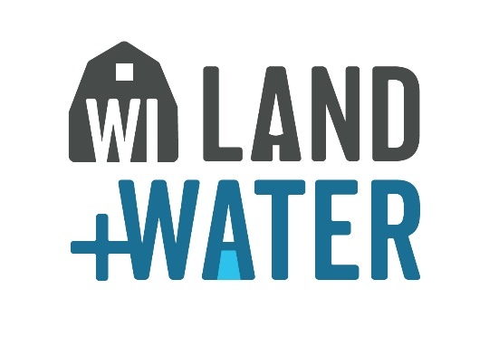

This certificate is presented to

having been the first place winner at the county level, and qualifying for participation in the Conservation and Environmental Awareness Speaking Contest sponsored by the INSERT NAME Area Association of Land Conservation Committees and Departments as part of a statewide program.

In recognition, the INSERT NAME Area Association hereby presents this certificate in appreciation of your contribution to the advancement of conservation and environmental awareness in Wisconsin.

Official Date

