**Wetland Restoration Planning Training**

**Objective:**  Planning wetland restoration sites in the field. This training will help conservation planners, biologists and engineering staff identify drainage features that drained this wetland and identify what conservation practices can be used to restore hydrology back to pre-drainage conditions. Participants will put together preliminary plans for this complex site which will include tile breaks, ditch fills, embankments, water control structures and seeding. Site is also located in a floodplain so we will discuss permitting.

**When:** **WEDNESDAY, April 20 OR THURSDAY, April 21st - 9:00 a.m. (sharp) to 3:00 p.m. (Rain or shine)**

Please note your date preference on the registration form or email Penny@wisconsinlandwater.org

**Where:** **Meet at the Farm located at W5031 Gem Avenue, Montello, WI 53949 in Marquette County.**

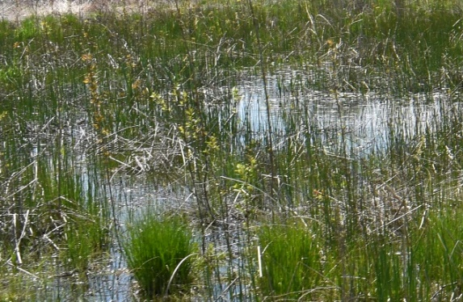

**Lunch:** Lunch will be provided by WI Land+Water on site.

A portable toilet will also be available on site.

**Needs: Be prepared to get dirty (bring boots as site can be very wet!!) Also, please bring field conservation tools of choice that you would use for planning (GPS, bucket auger, hand level, tile probe)**

**The Plan:** We will meet at the farm and discuss wetland restoration including programs WRE and CRP. Then we will split into groups to look at potential restoration areas. Groups will look at potential restoration practices including engineering and vegetative. After determining potential practices, we will determine post restoration hydrology and impacts. During the day we will take a break for lunch and then afterwards we will finish looking in the field and then get together and discuss each group’s plan for this wetland restoration and have discussion about these preliminary plans. The training will be led by Mark Steinfest, Tyler Maass, Brittany Ehlen, Scott Doherty, Tim Miland and Tally Hamilton.

Maps including Tile, Floodplain, Topo and Aerial will be handed out the day of training.

**Fun:** It is always good to look at real applications in the field and discuss options with other staff. Yes, this will be fun!!!!

**CEUs:** 5 CEUs for Conservation Planning Certification

**PDHs:** 5 PDHs for Engineering Job Approval

**Register at** ****[**https://conta.cc/3JYEsPi**](https://conta.cc/3JYEsPi) **by Friday, April 15, if you plan on attending. If you do not receive a confirmation email after submitting your registration or if you have questions, please contact Penny at** [**penny@wisconsinlandwater.org**](mailto:penny@wisconsinlandwater.org) **There is no charge for this training.**

**In case you are lost or late:**  Mark Steinfest @ (262)949-5537, Tyler Maass @ (608)477-5945