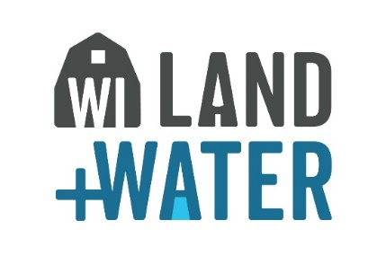

2023 Wisconsin Land & Water State Tech Tour
Hosted by Kewaunee County
Thursday, October 12th, 2023, 9:30 a.m.-3:15 p.m.
REGISTRATION FORM:
Name:__________________________________________________
County/Organization:______________________________________
Lunch will be provided by Homestead Kitchen & Tap (Sandwich, Chips and Drink)
Dietary Restrictions (check all that apply): ☐ Gluten Free ☐ Vegetarian ☐ Vegan
Other Dietary Restrictions or Allergies you think we should know (please list): ______________________________________________________________________

*Cost will be $15.00 per person. Please make Check payable to: Kewaunee County LWCD and mail it to Kewaunee County Land & Water Conservation Department, 625 Third St. Luxemburg, WI 54217
Please complete this registration form and email it to marcusen.terri@kewauneeco.org by October 4th, 2023. (RSVP is required.) If you have any questions, please contact contact Terri Marucsen at (920) 845-9700

PLEASE NOTE: We will depart from the Kewaunee County Land & Water Conservation Department, 625 Third St. Luxemburg, WI 54217. Check in at 9:30 a.m., load bus, & depart promptly at 10:00 a.m.

