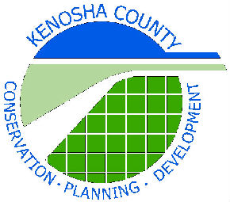
Kenosha County Land and Water Conservation Committee
& Kenosha County Division of Planning and Development

Are Pleased to Host the Southeast Area Wisconsin Land + Water Conservation Association Fall Tour Thursday, October 7, 2021
9:30AM – 2:30PM

Location: Petrifying Springs Park
5555 7th Street
Kenosha, WI 53144

Please join us on this very active walking tour in and around Petrifying Springs Park and nearby locations as we examine multiple projects designed to improve water quality, wildlife habitat, and natural resources management. We will be doing a considerable amount of hiking so please wear sturdy shoes and dress for the weather. If the weather forecast for the day is extremely poor, we will send a cancellation notice 24-hours in advance. Due to COVID & bus/driver shortages we will carpool to offsite locations (only 1-2 miles away) for afternoon.

Schedule (subject to change):
- 9:30-10:00 Registration at Pavilion #6, Petrifying Springs Park (see map)
- 10:00-12:00 Tour Phase 1 & 2 Petrifying Springs Pike River & Trail Restoration Projects
- 12:00-1:00 Lunch & SE Area WI Land + Water Business Meeting
- 1:00-2:00 Hawthorn Hollow, Regenerative Storm Water Conveyance, Wetland Restoration
- 2:00-2:30 UW-Parkside, Pollinator Patch Program, Storm Water Management

Cost: $20.00 Please make checks payable to: Kenosha County Div. of Planning & Development

Registration:

Name: ____________________________________ County: _______________________

Address: _______________________________________________________________________

City, State, Zip: __________________________________________________________________

Phone: ________________________________ Email: ________________________________

Return Registration to: Kenosha County Division of Planning & Development
Attn: Mark Jenks
19600 75th Street
Bristol, WI 53104

Registration Deadline: September 27, 2021
Questions: mark.jenks@kenoshacounty.org
262-857-1900

