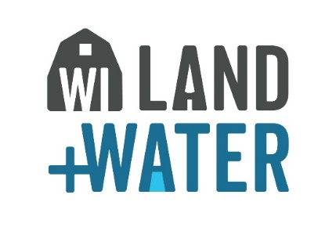
Itinerary | Time Schedule
Meet in Luxemburg (Coffee/Water & Donuts)  At Kewaunee Co LWCD, 625 Third St. Luxemburg, WI | 9:30 am (Bus will leave promptly at 10:00 am)
Zellner’s Composting Site | 10:15 am
Composting was a “thing of the past”, but more farms are looking into this method of Manure Management as a Tool to improve soil health, improve crop yields and reduce inputs. See how the Zellner’s Dixieland Dairy is able to take liquid manure from their Earthen Storage and turn it into a Soil Amendment with countless benefits. We will discuss each step Dave Zellner took to turn his idea into a Compliant Composting Operation.
Ebert’s Irrigation | 11:30 am
Hauling nutrient rich water can be costly and inefficient, but Irrigation can be a tool to help not only reduce cost, but also a means to deliver moisture and nutrients to a growing crop. New technology allows Ebert Enterprise to account for Public Health concerns, reduce the number of trucks on the road and deliver needed nutrients and moisture to their growing crops through Low Pressure Drip Irrigation. You will see the Pivot in action and learn how problems were solved through collaborative efforts with Ebert’s, NRCS and Kewaunee County LWCD.
Lunch at Ebert’s Homestead Kitchen & Tap | 12:30 pm
Bringing product to the consumer, Ebert’s Homestead Kitchen and Tap offers a farm-to-fork menu, bringing the community to the dinner table.
During lunch we will discuss issues surrounding Kewaunee County, steps we have taken to gather information, what we learned and how we have adopted and adapted to new regulation, methodology to prove Depth to Bedrock, how we map our findings and how we implement regulation.
Speakers: Davina Bonness (Kewaunee County Conservationist)
Dave Hart (Hydrogeologist, Wisconsin Geological and Natural History Survey)
ELNA Farm’s Field Visit (Depth to Bedrock Verification and Toolbar Tech) | 1:45 pm -2:45 pm
Learn how Travis Engels developed methodology to verify Depth to Bedrock for soils under 5 feet to Bedrock. How the methodology helped form the new DATCP Verification of Depth to Bedrock Technical Standard and how this field was a testing ground for various devises and methods of verification. (Dave Hart, Nathen Nysse (Tilth Agronomy) and Travis Engels)
View tools Commercial Manure Haulers are using to help achieve compliance with new Standards and steps they are taking to help prevent off site movement of manure. (Jeremy Heim)
Return to Luxemburg (Departure) | 3:15 pm

October 12, 2023 Kewaunee County Fall Tech Tour Schedule

RSVP Required- Please complete our registration from and email to marcusen.terri@kewauneeco.org no later than September 29th, 2023.

Cost is $15.00 per person. Make Check payable to: Kewaunee County LWCD and mail it to Kewaunee County Land & Water Conservation Department, 625 Third St. Luxemburg, WI 54217

Sites are in fields and pastures, so wear appropriate attire.

Questions? Contact Terri Marucusen at (920) 845-9700

