TO: County Land and Water Conservation Departments and Committees
RE: 2023 WI Land+Water Silent Auction to benefit Youth Education Opportunities
FROM: Megan Steckelberg, Adams Co. LCD, WI Land+Water Silent Auction Subcommittee Chair and Tracy Arnold, Portage Co. LCD, WI Land+Water Youth Education Chair
The 70th Annual WI Land+Water Annual Conference is March 1st - 3rd, 2023 at Chula Vista in Wisconsin Dells, WI. A popular fundraising and social event held during this conference is the Youth Education Silent Auction and we need you!
The proceeds from the silent auction help facilitate youth conservation programs across the entire state of Wisconsin, including your county. The Youth Education Committee has five core programs we conduct annually, such as; Conservation Poster Contest, Conservation Speaking Contest, WI Land +Water Middle School Conservation Camp, WI Land+Water High School Conservation Camp and the WI Envirothon. The proceeds from the silent auction help keep costs down for students interested in attending these programs. Whether its camp scholarships, team registration for National Envirothon, camp facility rentals, t-shirts or food cost, your efforts and donations are greatly appreciated and extremely beneficial.
Wisconsin is a diverse state and each county has something different to offer. This is your opportunity to highlight your county. Find a business, producer, local artist or county campground/golf course and ask them to donate an item that not only highlights your area of Wisconsin but benefits Wisconsin youth by keeping costs down for them.
Enclosed you will find all the materials you need to solicit donations from your area:
- Ideas list to get you started
- Template donation letter
- A “Why Donate” informational sheet
- A sample thank-you letter for you to thank your donors/contributors

We greatly appreciate your county’s effort to make the silent auction a success.
We look forward to your contribution and we will see you at the conference!

All donations are greatly valued and are tax deductible!
Tax ID#: 39-1448749
After two years, we are excited to be back in person for our annual conference. The last two years we held a virtual Conference and Silent Auction so donations were down however; in 2023, we are hopeful that all of our counties will participate in donating items for the Silent Auction.
Last year WI Land+Water created a new Middle School camp held at Upham Woods in the Wisconsin Dells. Adding a new program means, we have increased the number of Youth Education opportunities for students but it also means additional program costs that we need to cover in order to provide hands on conservation opportunities to youth across Wisconsin. Therefore, every dollar raised from the Silent Auction supports all of our Youth Education programs.

Suggestions for Auction Donation items
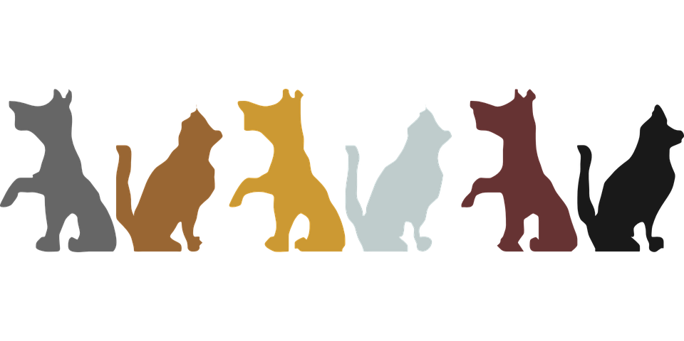
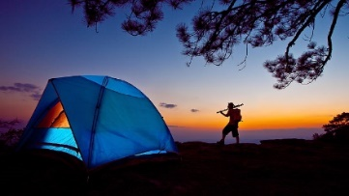
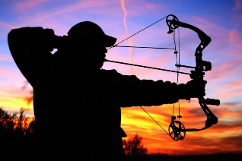
*But do not limit yourself to the items below think outside the box*
- Themed Gift Baskets
(Such as; Bloody Mary Fixings, Tailgater, Pet Themed)
- Hunting OR Fishing Gear
- Guided Fishing OR Hunting Trips
- Golf Packages
- Tickets to Games OR Shows
- Wine, Beer or Alcohol of any kind
- Passes for wine or beer tastings
- Camping Certificates, Cabin Rentals OR Hotel Stays
- Prints OR Original Pieces OR Artwork
- Any kind of food (refrigeration/freezer is provided at the conference)
- Home Décor Items OR Home Improvement Products
- Pet Products
- Toys OR Books
- Clothing (Such as; hats, shirts, sweatshirts, etc.)
- Zoo OR Museum OR Amusement Park Passes
Donate cash to WI Land+Water / Youth Education Committee.
Interested in donating cash? Contact kim@wisconsinlandwater.org
(A receipt/invoice can be provided by WI Land+Water for your Committee or County Voucher process)
SAMPLE DONATION REQUEST LETTER

DATE

COMPANY
ADDRESS
CITY, STATE, ZIP

Dear ???????????,

Wisconsin Land + Water Conservation Association has a Youth Education Committee focused on developing and maintaining programs that educate and inspire Wisconsin’s youth. Wisconsin’s unique eco-diversity makes it the perfect classroom and our programs work to ensure that future generations continue to care for our beautiful state. The Youth Education Committee has five core programs we conduct annually; Conservation Poster Contest, Conservation Speaking Contest, WI Land+Water Middle School Conservation Camp, WI Land+Water High School Conservation Camp and the WI Envirothon.

One of the Youth Education Committees biggest fundraising efforts is a silent auction that takes place at the WI Land+Water Conservation Association’s annual conference, held this year at Chula Vista in Wisconsin Dells, WI, on March 1-3, 2023. The proceeds from the silent auction help facilitate youth conservation programs across the entire state of Wisconsin, including your county. Whether its camp scholarships, team registration for nationals, camp facility rentals, t-shirts or food cost, your efforts and donations are greatly appreciated and extremely beneficial.

If you are a business, producer, local artist/hobbyist and have an item to donate that not only highlights your expertise, your area of Wisconsin and your generosity it will also greatly benefit Wisconsin’s youth.

Sincerely,
WI Land+Water Silent Auction
Subcommittee Members
Kim Warkentin -WI Land+Water Youth Education Director
Megan Steckelberg - Adams Co (Chair)
Cassie Kohls - Outagamie Co (Secretary)
Tracy Arnold - Portage Co
Ed Hernandez- Waushara Co
Brian Holt – Walworth Co
Kelly Maginnis – Columbia Co
Briana Enger – Columbia Co
Haillie Passow – Trempealeau Co

Name
Title

All donations are tax deductible.
Tax ID#: 39-1448749
Why Donate?
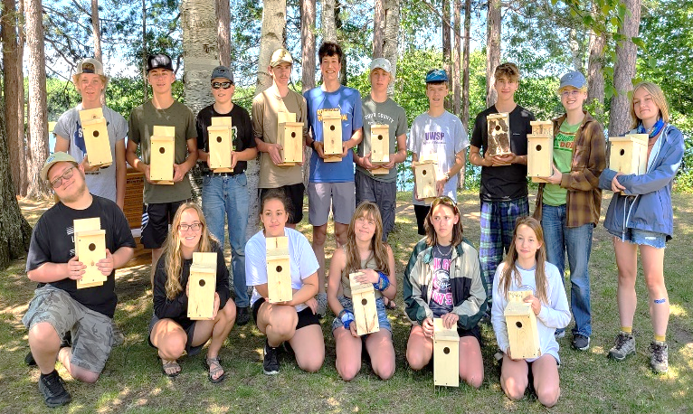
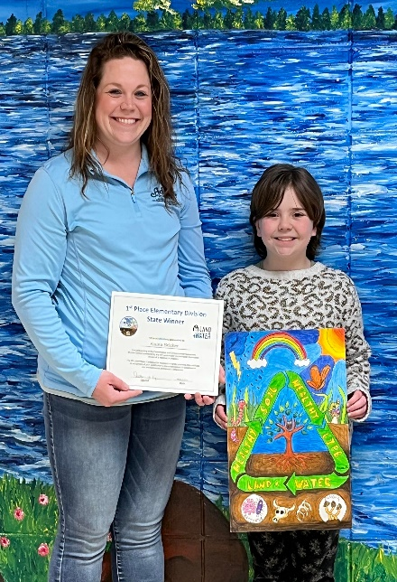
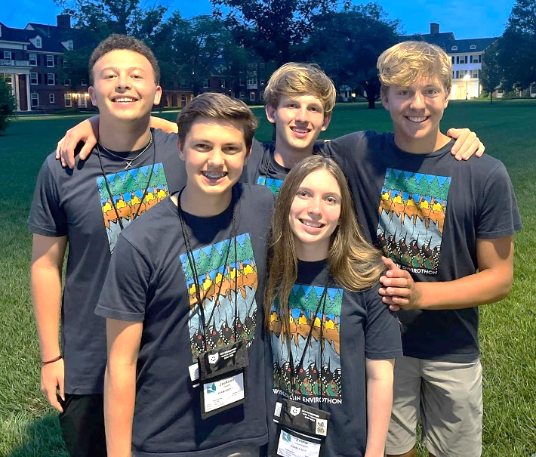
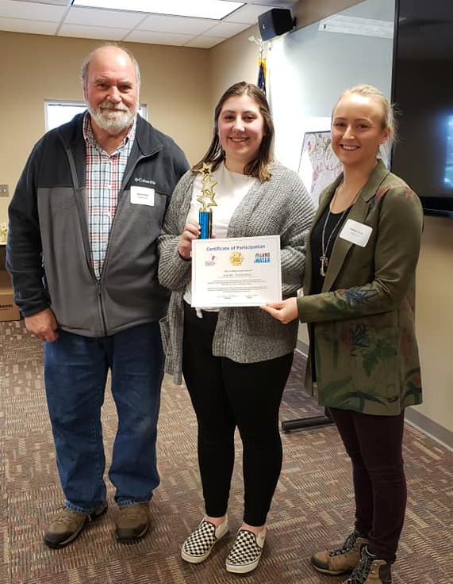
All proceeds from the silent auction are used to support statewide conservation youth education programs. Your donations create opportunities for students across Wisconsin to participate in our five core youth conservation programs.
WHAT IS WISCONSIN LAND+WATER CONSERVATION ASSOCIATION?
The Wisconsin Land+Water Conservation Association is a nonprofit, 501(c)(3) organization representing Wisconsin’s County Land and Water Conservation Committees (LCCs) and Land and Water Conservation Departments (LCDs) and governed by a Board of Directors. The LCCs and LCDs provide invaluable technical, educational, and financial services to protect and enhance natural resources in Wisconsin. Services are provided to a wide variety of local clients, including farmers, landowners, local governments, schools, civic groups, and other local conservation organizations. The LCCs and LCDs establish land use policies and are the primary local delivery system of natural resource programs. In addition, they sponsor conservation education programs, support public and private actions to advance resource conservation, work to increase public and private support for conservation, and sponsors an annual conference and other training opportunities.

SAMPLE THANK YOU LETTER
Date: Date

TO: XYZ Company

FROM: Your County LCC or LCD

SUBJECT: 2023 Wisconsin Land+Water Silent Auction Donation

Dear Contributor:

On behalf of the Youth Education Committee and the Wisconsin Land+Water Conservation Association, we would like to thank you for the generous donation. The item(s) donated supported the silent auction held at the Wisconsin Land+Water Annual Conference in Wisconsin Dells, WI on March 1-3, 2023.

All proceeds from the silent auction are to support the coordination and resources needed for local and statewide youth and education activities, including the State Conservation Awareness Poster and Speaking Contests, the Wisconsin Envirothon and support the Wisconsin Land+ Water Middle School and High School Youth Conservation camps. .

Wisconsin Land+Water is a nonprofit, 501 (C) (3) organization representing Wisconsin’s 72 County Board Land and Water Conservation Committees (LCCs) and Land Conservation Departments (LCDs).

For more information on our Youth Education Programs, please visit:
https://wisconsinlandwater.org/our-work/youth-education

All donations are tax deductible and are greatly valued. Thank you again for your kind support.

Sincerely,

Name
Title

Your contribution is tax-deductible as Wisconsin Land+Water is a 501 (c) (3) organization.
Federal ID #: 39-1448749

