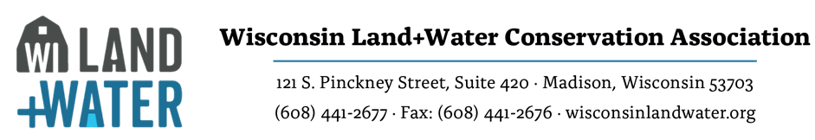

Technical Committee Meeting Agenda

Date: December 15, 2022 Time: 9:00am-12:00 pm Location: Zoom Only
PC/Laptop/Tablet/Smart Phone:
https://us02web.zoom.us/j/85744622720
Phone Dial-in: 312-626-6799; Meeting ID: 857 4462 2720
Mission: Lead WI Land+Water technical assistance activities related to the innovation, evaluation and implementation of conservation practices, standards, services, and the associated programs and policies.
Committee Members
☐ Matt Hanewall, Chair | ☐ Shawn Esser, Vice Chair |  |  |  | ☐ Tina Barone, Sec.
☐ Ketty Clow | ☐ Ben Dufford |  |  |  | ☐ Paul Fredrich |  |  | ☐ Brian Goepfert
☐ Erik Heagle | ☐ Paul Klose |  |  |  | ☐ Zach Mohr |  |  | ☐ Jonathon Lisowe
☐ Dan O'Connell | ☐ Ken Pozorski |  |  |  | ☐ Brian Smetana |  |  | ☐ Chad Trudell
Non-Voting Advisors
☐ Matthew Woodrow – DATCP |  |  | ☐ Mike Gilbertson – DNR |  |  | ☐ Eric Hurley - NRCS
WI Land+Water Staff Liaison (non-voting)
☐ Kate Brunner
Invited Guests

WI Land+Water meetings are open meetings. Individuals may observe in person, via conference phone, or via web conference if desired. Order and time allowed for agenda items may be changed due to pace of meeting or at the discretion of the committee chair. Please inform your chair if you cannot attend.

ALL AGENDA ITEMS ARE ACTIONABLE

- Call to order:
  - Roll Call - adopt agenda
  - Approve previous meeting minutes
- Technical Tour Review and Discussion (All)
- WI Land and Water News and Update on Technical Committee Mission (Brunner)
- SOC Update (Brunner)
- WDNR Update on Reissuance of Chapter 30 General Permit-15 and Creation of Hydro/Wetland Restoration General Permit (Nate Walker & Zach Mohr)
- Conservation Crop Rotation (NRCS 328) Revision Update (Mike Stanek)
- Floodplain Zone A Conservation Practice No-Rise Checklist: Example Site(s) Review (Clow et al)
- Wetland Rapid Functional Value Assessment (WRAM) Update (Esser)
- Direct Runoff from Feedlots Companion Document Subcommittee Update (Barone)
- ATCP 50 Rule Change Status: Silurian Bedrock & SWRM Programming (Woodrow)
- SITCOM (AITCOM) Update (O’ Connell)
- NRCS State Technical Subcommittee Updates (Engineering, Soil Health, Forestry, Wildlife, Urban Agriculture) (Esser, Petersen, Micheel, Schlupp and Osterman)
- 2023 Meeting Dates (Hanewall)
- Adjourn

