Certificate of Participation

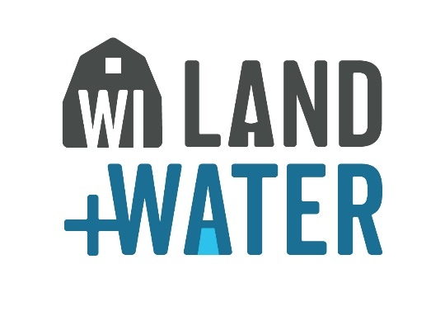

This certificate is presented to

For participating in the Conservation and Environmental Awareness
Poster Contest sponsored by the XXXX County Land Conservation Committees and Departments as part of a statewide program.

The XXXX County Land Conservation Committees and Departments hereby presents this certificate in recognition of your contribution to the advancement of conservation and environmental awareness in Wisconsin.

Official Date

